22/04/2024

Canteen Price Increases
Dear Parent/Carer,
I am writing to inform you that with effect from Monday 29th April 2024, the prices of food and drink in our current will be increasing.
Over the past 6 months we have been subject to numerous price changes from our suppliers, ranging from 3% up to 8.4%. These increases, partnered with national wage increases, energy costs and other operational costs have led us to take action.
We have tried to absorb the cost ourselves but sadly this is not sustainable for the school.
The following prices below will be in effect from Monday 29th April 2024;
All sandwiches/baguettes/wraps- £1.85
All breakfast items to increase by 5p
All snacks/drinks to increase by 10p
Meals to increase to £2.90

If you feel that your child may be entitled to free school meals, I would urge you to apply by emailing enquiry@ilsley.bham.sch.uk and requesting an application form.

Yours Sincerely,
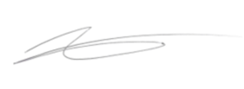
Adam Hicks
Senior Business Manager
Archbishop Ilsley Catholic School

