Thank you for your interest in the
Teacher of Religious Studies position
and your interest in joining the
Archbishop Ilsley family


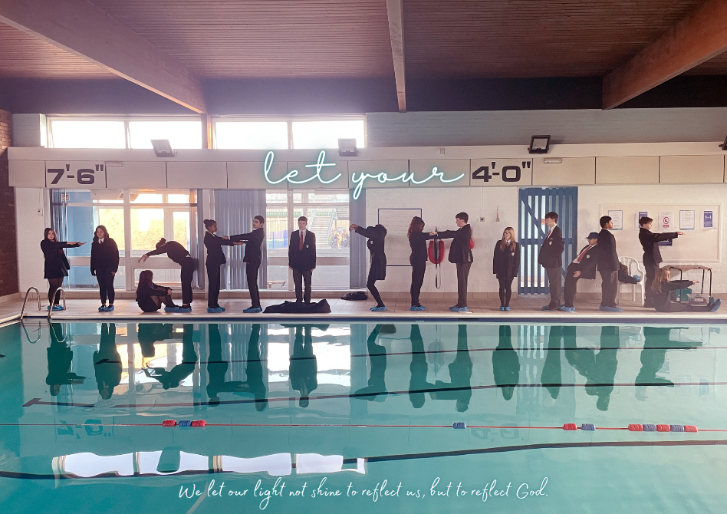

Proud to be part of the St Teresa of Calcutta Multi Academy Company
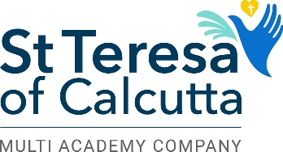

Welcome from our Head Teacher

Thank you for your interest in joining Archbishop Ilsley Catholic School.
The ethos of Ilsley is quite simple. As a Catholic school, we want pupils to “let (their) light shine.” We want pupils to believe in themselves and strive to fulfil their vocation, whatever that may be. Pupils are polite and friendly and a real joy to work with. They are the main benefit to working at Ilsley and this was our reflected in our recent CSI inspection. The findings of which you can find on our website under ‘Key Information’.
We have great facilities: as well as a spacious staffroom (we have briefing twice a week in there), we have a well-stocked library, a sports hall, gym, fitness suite, astroturf and a muga, as well as a swimming pool. The building is well maintained by our excellent site staff.
I hope you find this application pack informative and useful. If you read our schools newsletter, entitled ‘The ABI Update’ (which you can find under ‘communication’ on our website) or the posts from our Twitter account @ABIllsey, you will also get a flavour of what day-to-day life is like at Ilsley.
I also recommend you come to visit the school. Simply email recruitment@ilsley.bham.sch.uk and Katherine Duffy, Head of Department, would be happy to give you a tour and share her opinions about what it is like to work here. You can read more from Katherine below.
I look forward to receiving your application and meeting you in person.
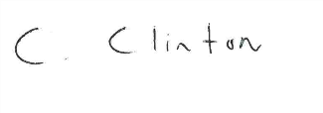
Ciaran Clinton
Welcome from the Head of Religious Studies
Dear potential candidate
Welcome to the Religious Studies department at Archbishop Ilsley. The RS Team is a close knit, supportive team who work collaboratively to plan and deliver a high quality and engaging curriculum. Pupils value Religious Studies and are keen to share their beliefs, thoughts and opinions. Religious Studies is regarded highly by all members of the school community and Religious Studies is a core subject.
Our assessment pathway is as follows:
Key stage 3 | Key stage 4 | Key stage 5
Diocesan Guidelines  Catholic Christianity | Eduqas  Specification B | OCR  Philosophy and Ethics  Development of Christian Thought  CORE RS

I hope you enjoy reading this pack and I hope to see you soon.
Katherine Duffy

Teacher of Religious Studies
Full time (negotiable)
Permanent contract
£31,650-£49,084



At Archbishop Ilsley Catholic School, our aim is to provide an excellent Catholic Education by providing the best care, support and outcome for each individual pupil. As a Catholic School, our mission is to make Christ known to all members of our community through the way we work and the way we act. We wish to appoint a dynamic and inspiring Religious Studies teacher to join a committed and dedicated team who work closely together to deliver to our pupils an engaging, rigorous curriculum from Year 7 to Year 13. As we looking for an exceptional RS teacher to join our committed team; we would be willing to discuss flexible working to ensure we can consider all interested candidates.

We are looking for someone who is:
- Committed to outstanding teaching and learning practices, which result in successful outcomes for our pupils.
- Committed to developing pupils' spiritual life as well as academic success.
- Able to uphold and promote the Catholic life of the school.
- Able to engage, motivate and inspire pupils.
- Enthusiastic with regard to curriculum implementation.
- Committed to high expectations.

You will play a central role, building on the strengths and successes of the Religious Studies Department and the school. These include:
- A culturally and socially diverse pupil body who behave well and enjoy RS.
- The promotion of the Catholic faith through the Catholic life of the school and RS curriculum.
- A team of supportive subject specialists who are passionate about delivering high quality lessons.
- A growing number of pupils are choosing to take RS at A Level.

This position is only available for candidates who have the right to work in the UK. We regret we cannot sponsor candidates from abroad or provide a work visa.

Archbishop Ilsley is a large oversubscribed Catholic Secondary School in Acocks Green on the border of Hall Green and Yardley in Birmingham, that caters for pupils between the ages of 11 and 18. There are 210 pupils in each year and the sixth form is predicted to grow considerably over the next five years. Our GCSE and A Level results are strong; GCSE results have increased by 10% over the last two years. We are very proud of our recent CSI Inspection and feel the report encapsulates the ‘Ilsley Spirit’.

Deadline for applications: Friday 30th January 2026 at 9am (early applications are encouraged and we reserve the right to withdraw this advertisement if we receive a sufficient number of applications)
Please send your completed CES application form to recruitment@ilsley.bham.sch.uk

Person specification for the role of Teacher of RS
Qualities and Attributes | Essential | Desirable | Evidenced By
Education and Training

Qualified Teacher Status |  |  | CES Teacher Application form
Honours Degree |  |  | CES Teacher Application form
Quality of Education

The ability to plan an engaging, yet rigorous, well sequenced series of lessons |  |  | Letter of application/Interview
An excellent classroom practitioner with a strong track record in observations |  |  | Letter of application/Interview
A range of strategies for keeping pupils engaged and focused |  |  | Letter of application/Interview
Knowledge of Eduqas  specification |  |  | Letter of application/Interview
An excellent subject knowledge |  |  | Letter of application/Interview
Personal Qualities and Characteristics

Enthusiasm and commitment to teaching young people |  |  | Interview
Good communication and inter-personal skills |  |  | Interview
Excellent organisational skills |  |  | Letter of application/Interview
A team player that looks forward to working with other like-minded colleagues in a thriving department |  |  | Letter of application/Interview
Ability to work under pressure and meet deadlines |  |  | Letter of application/Interview
A good health and attendance record |  |  | CES Teacher Application form

What staff say about working at Archbishop Ilsley Catholic School

“Staff are really friendly…really supportive… not judgmental.” Male maths teacher

“Colleagues are fantastic… very supportive.” Female maths teacher

“I love it… so glad I made the move.” Female RS teacher

“It’s lovely here… people are so kind… offering to do things for you.” Female PE teacher

“We’re a great unit… we’re a family.” Male DT teacher

“Everyone made me feel welcome.” Female member of the admin team

“Staff are phenomenal… we’re a community.” Male RS teacher

“I absolutely love it here.” Female D&T teacher

“I really like working here… staff are great.” Female member of support staff

“People are lovely… very supportive of each other. It’s not just a job.” Female maths teacher

“I love working here… I 100% feel at home.” Male Humanities teacher

“I’m not Catholic but I don’t feel excluded… we’re one big family.” Female Humanities teacher

“I feel privileged to work here.” Female TA

“There is great camaraderie… there is a buzz in the staffroom.” Female TA

“Staff are really talented, loyal and willing… people care.” Female English teacher

“We have phenomenal staff… we have the best middle leaders.” Male member of SLT

“I love this school… there are so many amazing people here… the pastoral team is amazing.” Female member of support staff

“I feel really lucky to work here.” Female PE teacher

“Ilsley is the centre of the community.” Male PE teacher

“I love this school… I love teaching here.” Male Humanities teacher

“Teachers are so open minded… they say ‘we’ll try it’.” Male TA

“Archbishop Ilsley is an extension of our own family.” Female D&T teacher

“I don’t think there is a person I would go to for help, and they would say no… it would be a ‘YES’ – without a doubt.” Female Art teacher

Staff happiness is our priority. Things that make Ilsley a special place to work

- Fantastic, talented and welcoming staff

- A swimming pool! (Staff can swim between 7am and 8am Tuesday and Thursday)

- Football after school on the astroturf (Wednesday after school - everyone welcome)
- Basketball after school on the gym (Friday after school - everyone welcome)

- A welcoming and friendly staffroom

- Secret Saints
- Free flu jabs

- An understanding of those juggling work and family life – time off for children’s first day at school, nativities, sports day etc

- Duke of Edinburgh – the best in Birmingham. A must for lovers of the outdoors and we’re always looking for more volunteers.

- A caring, supportive and understanding Headteacher and SLT

- No unnecessary meetings

- A workable marking and feedback policy

- Great extra-curricular opportunities (theatre, House of Parliament, dance competitions, Berlin, Battlefields, Global Links culminating in a June trip to Peru)

- The only secondary school to have a float in the famous St Patrick’s Day Parade in Digbeth!

- End of term celebrations

- Cycle to Work scheme

Job description

Post Title: Teacher of RS

Start date: Negotiable (Easter 2026 or September 2026)

Post Purpose:
To uphold the Catholic Life and Mission of the school.
To raise standards of pupil attainment and achievement within their area of curriculum responsibility.
To be accountable for pupil progress within the curriculum area.

Reporting to: Head of Religious Studies

Working Time: Full time (negotiable) permanent contract

Salary/Grade: MPS/UPS

Disclosure Level: Enhanced

General Duties

Teaching RS to designated classes of pupils and general welfare of a tutor group in accordance with the requirements of the latest School Teachers Pay and Conditions Document and the National Standards for Qualified Teacher Status, having due regard to the requirements of the National Curriculum, the school’s aims and objectives, schemes of work and any policies of the Governing Body. To share in the corporate responsibility for the well-being and discipline of all pupils and to actively support the aims and values of Archbishop Ilsley Catholic School.

Specific Duties
- Teaching
  - Plan work in accordance with departmental schemes of work and programmes of study.
  - Liaise with relevant colleagues on the planning of units of work for collaborative delivery.
  - Work in collaboration with Teaching Assistants attached to any teaching group.
  - Take account of pupils’ prior levels of attainment and use them to set targets for future improvements.
  - Set work for pupils absent from school for health or disciplinary reasons.
  - Maintain good discipline by adherence to the Teacher Standards.
  - Set high expectations for pupils’ behaviour by establishing a purposeful working atmosphere in accordance with the school’s behaviour policy.
  - Set appropriate and demanding expectations for pupil’s learning, motivation and presentation of work.
  - Develop own subject knowledge to a high level of expertise.

- Pastoral Work

- Have a full understanding of the procedures for safeguarding.
- Undertake responsibility for a tutor group as required
- Be the first point of contact for parents of pupils in the tutor group.
- Monitor and set targets for the social and academic progress of individuals in the tutor group.
- Promote good attendance and monitor in accordance with the school’s attendance policy.
- Deliver the designated tutor time programme.

Assessment, recording & reporting

  - Maintain notes/plans of lessons undertaken and records of pupils’ work.
  - Mark, monitor and return work within a reasonable and agreed time span providing constructive oral and written feedback and clear targets for future learning as appropriate.
  - Carry out assessment programmes (e.g. reports) as agreed by the school or faculty.
  - Complete pupil records of achievement in line with policy and as specified in the published calendar.
  - Attend the appropriate parents’ evenings to keep parents informed as to the progress of their child.
  - Be familiar with the SEND Code of Practice for identification and assessment of Additional Educational Needs and keep appropriate records on Individual Education Plans for pupils.

Professional Standards

  - Support the aims of the school to promote a ‘learning community’.
  - Treat all members of the community, colleagues and pupils, with respect and consideration.
  - Treat all pupils fairly, consistently and without prejudice.
  - Set a good example to pupils in terms of appropriate dress, standards of punctuality and attendance.
  - Promote the aims of the school by attendance at and participation in events such as open evenings, options evenings and the like (as appropriate to their responsibilities.)
  - Support the ethos of the school by upholding the behaviour code, uniform regulations, etc.
  - Take responsibility for their own professional development and participate in staff training when provided.
  - Reflect on their own practice as well as the practices of the school with aim of improving all that we do.
  - Read and adhere to the various policies of the school.
  - Participate in the management of the school by attending various team and staff meetings.
  - Undertake duties as prescribed within school policies.
  - Ensure that all deadlines are met as published in the school calendar.
  - Undertake professional duties that may be reasonably assigned to them by the Head teacher (e.g. cover, etc).
  - Be proactive and take responsibility for matters relating to health and safety.

This job description may be amended at any time in discussion between the Head Teacher and yourself but in any case will be reviewed before the commencement of the next Performance Management cycle.

Signatures:

This job description is current at the date below but will be reviewed on an annual basis and following consultation with you, may be changed to reflect or anticipate changes in the job requirements which are commensurate with the job title and grade.

Signed………………………………(Teacher) Signed……………………………….(Head Teacher)

Dated……………………………….(Teacher) Dated ……………………………….(Head Teacher
Safeguarding commitment

Archbishop Ilsley is committed to safeguarding and promoting the welfare of all its pupils. We believe that:
- Our young people have the right to be protected from harm, abuse and neglect;
- Our people have the right to experience their optimum mental and physical health;
- Every child has the right to an education and young people need to be safe and to feel safe in school;
- Young people need support that matches their individual needs, including those who may have experienced abuse;
- Our young people have the right to express their views, feelings and wishes and voice their own values and beliefs;
- Our young people should be encouraged to respect each other’s values and support each other;
- Our young people have the right to be supported to meet their emotional, social and mental health needs as well as their educational needs. Our school will ensure clear systems and processes are in place to enable identification of these needs. Including consideration of when mental health needs may become a safeguarding need;
- Our school will contribute to the prevention of abuse, risk/involvement in serious violent crime, victimisation, bullying (including homophobic, biphobic, transphobic and cyber bullying), exploitation, extreme behaviours, discriminatory views and risk-taking behaviours.

All staff and visitors have an important role to play in safeguarding young people and protecting them from abuse and considering when mental health may become a safeguarding issue.

Please be aware, as part of our rigorous safer recruitment process, we will undertake the following pre-appointment checks if you are successful on the interview day:

- Verification of identity – including an original birth certificate;
- Eligibility to work in the UK;
- An online search;
- DBS Barred List (if a teacher, cover supervisor or pastoral lead);
- Enhanced DBS check;
- That you are not subject to a prohibition order or GTCE restriction;
- That you are not subject to a TS128 prohibition from a management position (if grade 4 or HOD or SLT);
- Qualifications (including degree certificate and A Level results);
- QTS certificate;
- Overseas check may be made if you have lived abroad;
- Two references will be requested and verified.

As a new employee, you will be expected to uphold and promote our strong safeguarding culture.

